Episode 103: Currents and Charge Carriers

There are two main aims for this episode: to present a range of examples involving different types of charge carrier, and to measure currents and link the measured current to rates of flow of charge.
Lesson Summary
- Demonstration: Identifying charge carriers (20 minutes)
- Demonstration: An electron beam (15 minutes)
- Demonstration: Students conducting electricity (15 minutes)
The episode consists of a series of demonstrations which could be set up as a circus before the lesson. The students can then be taken around as each one is discussed.

Demonstration: Identifying charge carriers
Students are used to thinking of metals as good conductors. However, they should appreciate that there are other situations, more or less familiar, in which current flows.
In a filament lamp: Conductor: metal (tungsten). Charge carriers: electrons. Remind them of the free-electron model (i.e. in a metal, there are free electrons which can move about within the metal). Discuss the behaviour of the charge carriers as the supply voltage is increased. (They move faster to make a bigger current.)

A spark through air: The level here is variable. The essential idea involves ionisation. You could ask why air is usually a good insulator and what must happen in order for it to break down and conduct. The charge carriers are positive ions and electrons. These move in opposite directions. Link this to lightning.
A fluorescent tube: Conductor: Plasma. Charge carriers: ions and electrons. Plasma is the 4th state of matter and is the most common phase of matter in the universe (e.g. in stars).
Electrolysing copper sulphate solution with copper electrodes: Conductor: Electrolyte. Charge carriers: positive (copper) and negative (sulphate) ions.
So both electrons and ions are charge carriers; when they move, a current is flowing.
Episode 103-1: Identifying charge carriers (Word, 39 KB) - see end of document

Demonstration: An electron beam
Show the path of beam of electrons in a vacuum tube. You will need to practice setting this up; follow the manufacturer’s instructions.
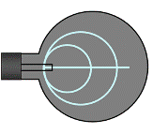
Conductor: charged beam in a vacuum. Charge carriers: electrons. The high speed and low density of charge in the beam can be contrasted with the low speed and high density of charge carriers in a metal (this helps to lead into the derivation of I = nAqv if your specification requires it).
Episode 103-2: Current and charge in electron beams (Word, 53 KB) - see end of document

Demonstration: Students conducting electricity
This can be used to show the effect of series and parallel circuits. It can also lead to a discussion of electric shock and electrical safety. It takes a few tens of milliampere to kill a person. A car battery can supply hundreds of ampere if it is shorted, but 12 V is not sufficient to push a tangible current through a person. The amount of current depends on the contact resistance and path of the current through the body. We conduct because much of our body is effectively an ionic electrolyte (like salty water).
Episode 103-3: Conduction by students (Word, 122 KB) - see end of document

Episode 103- 1: Identifying charge carriers

Demonstration 1: A filament lamp
Apparatus: e.g. 12 V lamp and variable (12 V max.) power supply. Or mains lamp and a variac. This is simply an example of a metallic conductor. As the voltage is increased more current flows and more energy is transferred to light and heat.

You could discuss the mechanism of energy transfer in terms of increasing rates of electron/ion collisions, but this is not necessary at this stage (unless it helps to reinforce the idea of electrons as physically real charge carriers.)

Demonstration 2: A spark in air
If you have one, use a Van de Graaff generator to create sparks - an alternative is a piezo-electric igniter for a gas hob (although this is more difficult to see (especially if the class is large).

Apparatus: Van de Graaff generator and earthed sphere.
Procedure: Turn on the Van de Graaff generator keeping the earthed sphere well away from it. Let it charge for about 1 minute and then bring the earthed sphere close (within 10 cm) to the surface of the charged dome. A sharp spark discharge will be seen and heard. This repeats as the generator recharges.
Advice: Set this up and check it immediately before the lesson. It will work best on cold dry days. Performance can be improved if a hairdryer is used to dry the surface of the belt and dome prior to use. There is often a hole for a 4mm lead in the base of the Van der Graaff for an earthing lead, which will help too. Make sure you discharge the dome after turning off the motor so that no one will be surprised by a shock from the residual charge! (To discharge the dome make sure the motor supply is switched off, then hold a wooden ruler on the dome for a few seconds whilst touching a wooden bench. Finally touch the earthed sphere and dome.)

Be safe
You need to be aware of any medical reasons why it would be inadvisable to allow these very small currents to pass through the students in your care, if you wish to let them take part in the demonstration. Reasons might include heart irregularities and a tendency to epilepsy. Consult the appropriate advisory manual. (In Scotland this would SSERC, www.sserc.org.uk, in the rest of the UK, the employer’s guidance, usually the CLEAPSS CD-ROM.)

Demonstration 3: Fluorescent tube
Many laboratories will have fluorescent lights. These can be pointed out as an example of conduction through a plasma.
You can also get a small fluorescent tube to light up in a darkened room if you hold it near to the charged Van de Graaff generator. Any earthed object must be well out of the way. The tube must be held close enough the get a spark, and if held half way down its length will light up only in the section between your hand and the Van de Graaff.

Demonstration 4: Electrolysing copper sulphate solution

¹Wear safety spectacles
Ensure you wear safety spectacles throughout this experiment.
Although eye protection is strictly not necessary with this strength solution, it is policy in most schools and colleges to wear it.
²Take care with hazardous chemicals
The chemicals in use here should not be brought into contact with the skin or ingested.

Apparatus
A rectangular tank containing copper sulphate solution (0.5 molar is suitable, do not use stronger than 1 molar) to a depth of about 2.0 cm; copper plate electrodes (e.g. 5 cm by 10 cm); battery pack or low voltage d.c. supply; demonstration ammeter (visible to class).

Procedure
Connect up the circuit and observe the current. Adjust the depth of immersion and separation of the plates, both affect the current and can lead to a discussion of the number and rate of motion of the charge carriers (ions). This could also be linked to resistance (dependence on length and area) and to the equation I = n A q v (although A is not really so well defined since ions are not confined to a rectangular tube between the electrodes).
Episode 103- 2: Current and charge in electron beams

Watching television
Every time you watch a conventional television you are seeing light given out as a fine beam of electrons hits the phosphor on the screen. The beam scans in rows to build up the picture. The beam is accelerated by a potential difference, and because the charged electrons are moving it is also an electric current. This demonstration is a chance to see how electron beams work, in something simpler than a television set.

Requirements
- electron deflection tube
- 2 EHT power supplies, 0–5 kV dc, or 1 EHT and 1 HT supply with SPECIAL LEADS (see later)
- 2 demonstration digital multimeters
- leads, 4 mm
Wire carefully, no bare conductors, even for heater connections.
If an HT supply is used, the leads must use 4mm plugs with shrouds to prevent accidental contact.
Shrouded leads and the large protective resistor are in use to prevent dangerous currents passing though humans.
The 5 kV supply used must be an educational type with an output current limited to less than 5 mA.
Electron charges in motion in a vacuum
One simple demonstration tube uses a pair of deflection plates in the path of fast moving electrons. A metal filament (cathode) is heated to white heat. Electrons boil out of the heated filament, and then they can be made to travel across the tube. To do so they have to be pulled away from the filament as a result of the potential difference between it and a nearby plate, the anode. The anode has a hole in it, and some electrons go through the hole and travel across the tube. The plate in the tube is coated with phosphor and may glow blue or green.
1 MΩ
1 MΩ
0 - 5 kV
6.3 V ac
coiled filament
0 – 5 kV
metal can with hole in
pair of metal plates
whitish phosphor screen
glass sphere
The potential difference (or strictly the electric field) between cathode and anode which accelerates the electrons has to be quite large (a pd of several kV). As it is increased, the energy given to the electrons increases and the phosphor glows more brightly. The anode must be positive. If it is negative, no electrons are pulled from the region near the heated cathode. This helps to show that electrons themselves are negatively charged.

If the 5 kV supply is connected across the plates the electrons are deflected. This is further evidence that they are charged. This deflection shows up as a curve on the phosphor coated plate.

Note that the heater connections will be thousands of volts below earth potential and that the resistors must be enclosed to prevent accidental contact.

You have seen that
1. Electrons can be 'boiled off' a heated metal.
2. Electrons have a negative charge, and repel one another.
3. Electrons can be accelerated by a potential difference, to form a beam of moving charges.
4. A beam of moving electrons is an electric current.
5. The moving electrons in a beam transfer energy (power = current × potential difference).
Practical advice
This demonstration shows how electron currents can be made to flow through a vacuum tube and show some properties of the beam. These are charge and energy transfer and electric deflection by charge distributions within the tube.
These notes assume an electron deflection tube is used. If this is not available then a Maltese cross tube does just as well.
Start by explaining the action of the electron gun, as the circuit is built up. The filament is run from the standard 6.3 V ac connections on the EHT supply. It glows white hot.
The thermionic emission from the hot cathode creates a space charge around the filament (electrons 'boil off' the filament and surround it).
The electrons can be accelerated towards the anode if it is made positive with respect to the cathode. The filament is connected to the negative EHT terminal. Some electrons hit the anode and return to the positive terminal of the EHT supply (usually earthed). This current can be monitored with a milliammeter in the return wire.
As the pd is increased to a few thousand volts, some electrons travel across the vacuum to hit the screen and make it fluoresce. The larger the potential difference the more the kinetic energy gained by the electrons and the brighter the fluorescent screen glows.
If the polarity of the EHT is reversed there is no beam or fluorescence at the screen. This diode action shows that the moving charge in the beam is negatively charged. NB: switch the power off before changing the connections to avoid unpleasant shocks.
Electric deflection of the cathode rays is demonstrated by connecting a second EHT supply across the deflection plates.

Technician's note
The demonstration is more effective in a darkened lab, with control of the room lights as the circuit is built up in stages.
An HT supply (0 to 300V) would be sufficient to show a small deflection but THIS SUPPLY IS MUCH MORE HAZARDOUS. This supply can only be used by a teacher using special leads with shrouded 4mm plugs; it must always be switched off before changing any connections.

Alternative approaches
A variety of vacuum tubes could suit this purpose. If the demonstration is performed with a Maltese cross tube, the filament glows white hot, casting a shadow of the cross on the front of the tube (light travels in straight lines), the electron beam also casts a linear shadow, corresponding to the light shadow, showing that the electrons also travel in straight lines here.
Electric deflection of the cathode rays is easily demonstrated by turning down the EHT and disconnecting the cross from the anode. By letting it float electrically the incoming electron beam will start to charge the cross negatively and to repel the electrons in the beam. The fluorescent Maltese Cross shadow swells to the form of a four-leaf clover, but the light shadow remains unaffected The effect becomes greater as the gun voltage is increased and the cross charges to a higher equilibrium potential with more charge on it.
A variety of vacuum tubes could suit this purpose. If the demonstration is performed with a deflection tube, a separate voltage source will be required to run the deflecting plates. The fine beam tube although giving the opportunity to visualise the beam through low pressure gas ionisation, cannot easily show electric deflection. Magnetic deflection of the beam is premature at this stage.

Social and human context
The electron was discovered little more than a hundred years ago. In those four generations, it has become a working tool in many new technologies, notably information and communication technology. But it also remains one of the fundamental particles of matter, whose quantum behaviour also helps determine the differences between chemical elements and compounds. Used in electron microscopes, electrons help us to picture matter on very small scales.
External references
This activity is taken from Advancing Physics Chapter 2, 20D
Episode 103- 3: Conduction by students

People as electrical conductors
Electricity was once the wonder of the age. Electrical demonstrations were performed before kings and queens. There are engravings of, for example, courtiers suspended by (insulating) silken ropes being used as electrical conductors, even – perhaps dangerously – giving an electric shock to a ring of people hand in hand making a circuit. Today, electricity is commonplace, and you will have been taught from a baby not to play with it. Being made largely of salty water, your body conducts electricity quite well.

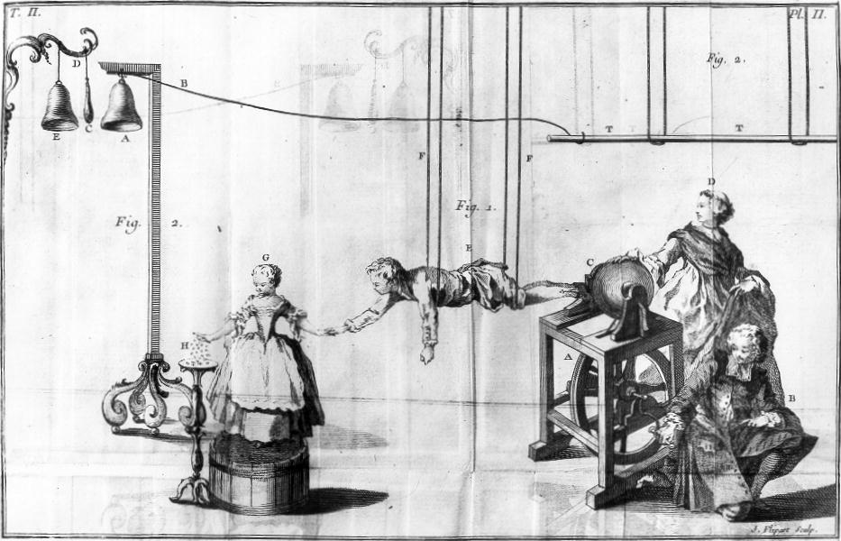 | The Burndy Library, Dibner Institute for the History of Science and Technology

Requirements
✓ power supply, 5 V dc
✓ microvoltmeter (a light-spot galvanometer)
✓ 4 mm leads
✓ class of student volunteers!

How well do you conduct?
A group of up to ten volunteers join hands to form a ring. The ring is broken at one point and a 5 V power supply and sensitive galvanometer is introduced into the 'person circuit'. The light beam of the galvanometer swings across, showing that there is an electric current running through the ring of people. How much current flows? Does anyone feel anything? How well do the people conduct?
The current is small, perhaps 10 or 20 μA. Nobody feels anything.
Try one volunteer only. The current is larger, perhaps 100 to 200 μA. The person still feels nothing (usually - some people can just detect currents at this level).

Danger or not?
Torch batteries are not dangerous because although they can produce relatively large currents (in low resistance circuits) they do so at safe low potential differences, and only a small current actually flows through the body.
An electrostatic generator like the Van de Graaff (or like your shoes scuffing a nylon carpet) is not dangerous because it only produces a harmlessly small current even though at a very high potential difference. It is the combination of potential difference large enough and a source resistance small enough to make the human body conduct substantial currents that matters.
Potential differences up to about 30 V are thought to be safe enough. Beyond that high tension supplies of 100 V or more, or EHT supplies of 1 kV or more, can be lethal if the current supplied is sufficient. Currents of a few microamps are not felt. Those around 1 mA are uncomfortable for the average human, but not lethal. Once several milliamps or more are conducted, especially if near the heart, then cardiac arrest or fibrillation (irregular heart muscle activity) can result. The conductance of the body is largely dependent on the state of the skin and pores, being high if they are wet or sweaty. It is for this reason that light switches are usually placed outside bathrooms, or if inside, are operated by an insulating cord. The body fluids inside the skin are quite good conductors due to their ion content, and if the skin resistance is breached by sparking, substantial currents can flow through the body.

Outcomes
Your body conducts electric current, a few tens of microampere for each volt of potential difference across it. So for 1000 V the current reaches tens of milliamperes (if the source can supply it), which is big enough to be lethal. But your resistance can vary a lot – people have been killed by just over 50 V; 230 V kills regularly.

Practical advice
Here we demonstrate that students conduct electric current, albeit in small quantities if the voltage supply is low. Conductance can be defined, measured and compared to the more familiar reciprocal quantity resistance. This is intended to be a straightforward, quick, fun demonstration to introduce conductance.

Make a series circuit with all the (willing) students clasping hands, a 5 V dc power supply and the galvanometer, measuring the unfelt current around the complete loop. The current will depend on many factors including dryness of students' skin. Typically for a ring of ten students currents are around tens of μA, so the galvanometer will need to be set at an appropriate sensitivity.

To calculate the total conductance, divide the current by the potential difference. To calculate the conductance of per student, first divide the potential difference by the number of students. Typical values for one person are about 30 kΩ or 33 mS.

If any pair of hands breaks contact the conductance falls swiftly to zero and so does the current. Students enjoy the effect of this on the light beam galvanometer, which is easier to observe in a partially darkened lab. Individual conductances can be measured, and are the basis for some lie detector tests (if you sweat when you lie)! Students may be surprised that they cannot detect currents at this level, and useful discussion about electric shocks, cardiac arrest, fibrillation and defibrillation can follow.
The variable contact conductance and the possible excitement of the students mean that their conductances are not constant enough to perform the obvious follow up. This would be to connect students in parallel and show that their conductances add, although it might be fun to try. This would have to be demonstrated with fixed conductors.

It is worth reminding students that the energy transferred to electrons by chemical reactions and cells is relatively modest, being typically 150 kJ per mole. This translates to a few electron volts (eV) per electron. So the energy per coulomb for typical chemical cells is 1 or 2 volts.

Cells give electrons a rather small amounts of energy, but can produce substantial flows of charge by reacting chemicals in largish numbers of atoms per second. If a cell produces a current of 0.2 A it produces
n = I / e = 0.2 A / 1.6 × 10^{–19} C = 1.3 × 10¹⁸ electrons per second.

This is a very large number, but is only a small fraction of a mole, so cells can produce quite large charge flows over substantial times before their chemicals are all reacted.

Alternative approaches
A more formal class practical could be run using resistance substitution boxes and a digital multimeter and calculator to bring out the relationships between conductance and resistance.

Social and human context
Electric shock, danger from high voltages including the mains. The importance of current level on severity of shock. Cardiac arrest and fibrillation and the process of defibrillation. The morality of using electric shock 'therapy' in dealing with the mentally disturbed.
External Reference: SATIS 16–19 Unit 25, Why 50 Hz?

Be safe
Again you need to be aware of any medical reasons why it would be inadvisable to allow these very small currents to pass through the students in your care. Reasons might include heart irregularities and a tendency to epilepsy.

External references
This activity is taken from Advancing Physics Chapter 2, 60E

